INTERNSHIP TASK _ 3

Company : CODTECH

Topic : DATABASE MIGRATION

Name : Devangam Narayanaswamy Veena

College : Sri Venkateshwara College of Engineering

Branch : Information Technology

Semester : B.Tech , 5th Semester (completed 2nd year)

# ⧫ Objective :

This task demonstrates how to migrate data from a MYSQL databases to a PostgreSQL database while ensuring data integrity, structure consistency, and accurate data transfer.

# ⧫ Database Details :

MySQL Source Database : company_db

Table : Employees

CREATE TABLE Employees (

Id INT PRIMARY KEY,

Name VARCHAR(100),

Department VARCHAR(50),

Salary DECIMAL( 10, 2 ),

Joining_date DATE

);

INSERT INTO EMPLOYEES VALUES

( 1, 'veena', 'HR', 45000.00, '2025-07-15' ),

( 2, 'meghana', 'IT', 55000.00, '2025-07-20' ),

( 3, 'chinni', 'Finance', 65000.00, '2025-07-25' );

# ⧫Migration Process Steps :

### Step 1 : Export MySQL data

Export the table to a CSV using the command:

SELECT * FROM Employees

INTO OUTFILE '/tmp/employees.csv'

FIELDS TERMINATED BY ' , '

ENCLOSED BY ' '' '

LINES TERMINATED BY '\n';

### Step 2 : Create PostgreSQL Table

Login to PostgreSQL and run:

CREATE TABLE Employees (

Id INTEGER PRIMARY KEY,

Name VARCHAR(100),

Department VARCHAR(50),

Salary NUMERIC( 10, 2 ),

Joining_date DATE

);

### Step 3 : Import Data to PostgreSQL

Use PostgreSQL COPY command:

COPY Employees( Id, Name, Department, Salary, Joining_date )

FROM '/tmp/Employees.csv'

DELIMITER ' , '

CSV HEADER;

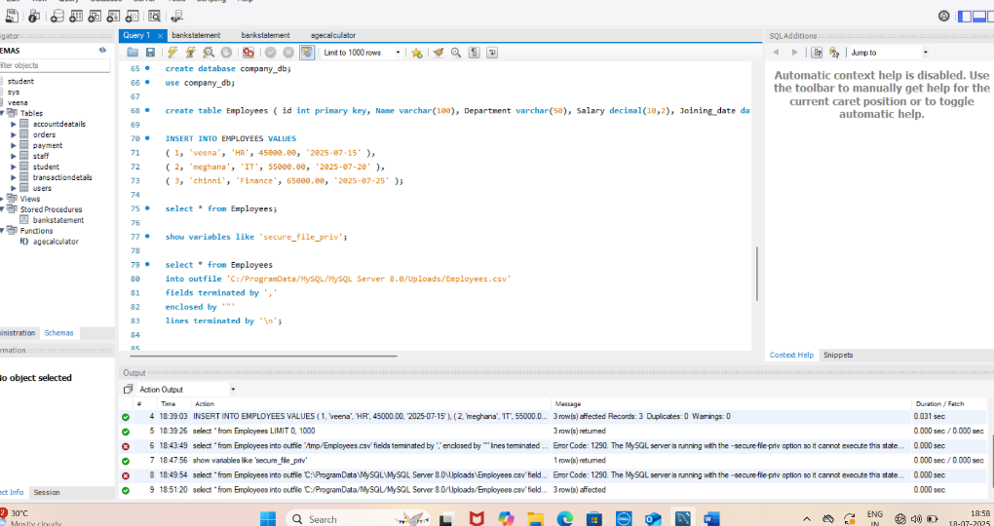

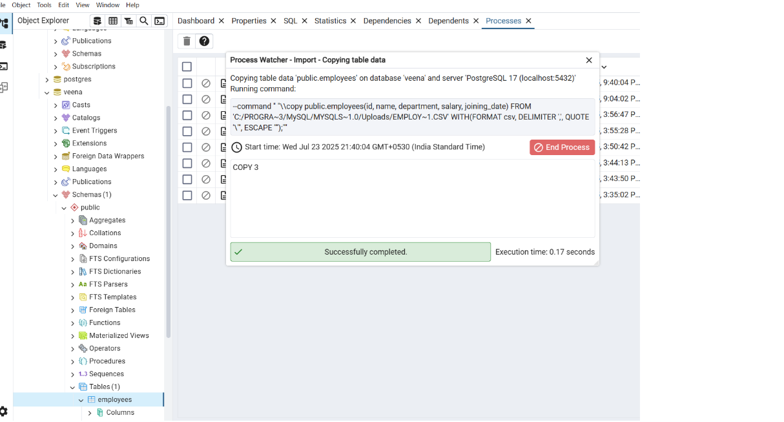

# ⧫ Data Integrity Verification :

• Row Count Match

In MySQL

SELECT COUNT(*) FROM Employees;

In PostgreSQL

SELECT COUNT(*) FROM Employees;

•Sample Record Comparison

SELECT * FROM Employees WHERE Id=1;

• Data Types Check

Ensure matching datatypes : INT↔INTEGER, DECIMAL↔NUMERIC, DATE↔DATE

# ⧫ Migration Summary Report :

### Step Description:

Source DB MYSQL (company_db)

Destination DB PostgreSQL (company_db_pg)

Tables Migrated employees

Data Export Format CSV (Comma Separated Values)

Pata Volume 3 records

Integrity Check Row count matched,

values matched,

Sample

No data loss detected

Tools Used MySQL CLI, pgAdmin, PostgreSQL CLI Challenges File path access, format compatibility. Resolution Used compatible data types and validated file permissions.

# ⧫ Conclusion:

The migration from MySQL to PostgreSQL was successfully completed using standard export/import techniques. All records and structure were preserved, with zero data loss. Verification confirms that data integrity is maintained.